PRESS RELEASE

YES BANK launches ‘Scale-Up’ series to upskill MSMEs

Collaborates with Spark Minda as its first Corporate Anchor to train their Tier suppliers scale-up their businesses

- Top 50 MSMEs Suppliers of Spark Minda, Ashok Minda Group identified for pilot YES BANK MSME ‘Scale Up’ Workshop
- MSMEs to be skilled with latest tech know-how, global best practices and financing
New Delhi, 4th June, 2018: YES BANK launches MSME ‘Scale-Up’ series, a unique Industry-Academia collaboration, to upskill MSMEs from Tier 2 and Tier 3 cities with MDI Gurgaon as its Training Partner and Spark Minda, a global entity in automotive components. The initiative is aimed at boosting MSME businesses by educating them on latest manufacturing technologies, global best practices and innovative finance management.
The maiden chapter of the Series kicked off in MDI Gurgaon, in collaboration with the first Corporate Anchor ‘Spark Minda’. The curriculum of the pilot workshop has been jointly designed by Management Development Institute (MDI), Spark Minda Supply Chain Heads and YES BANK’s MSME subject matter experts. Spanning across 2 days, the residential training program was attended by top 50 promoter-level MSME suppliers of Spark Minda, Ashok Minda Group on 31st May & 1st June, 2018.
This is the first of the series of similar workshops planned in partnership with different Corporate Anchors across industries during the year.
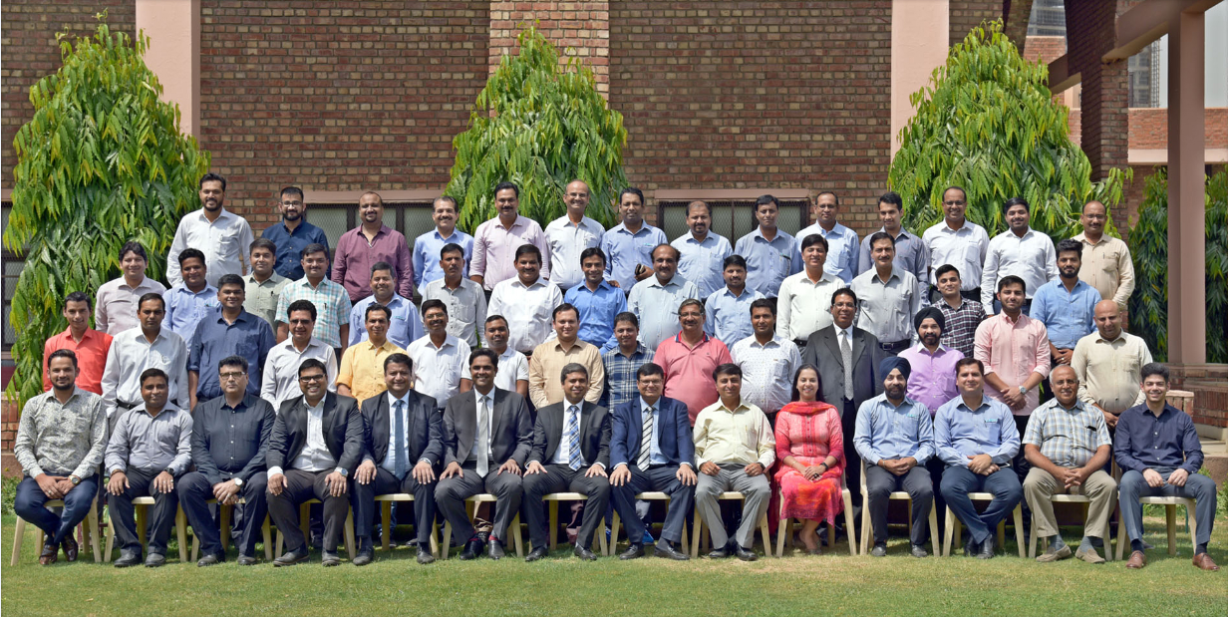
Officials from top MSMEs participate in YES BANK’s MSME ‘Scale-Up’ training program at MDI, Gurugram
Commenting on the initiative Mr Rana Kapoor, Managing Director & CEO, YES BANK said, “India’s MSMEs have played a key role in its economic development, accounting for almost 45 % of industrial output and over 8% of GDP. YES BANK is committed to being a one stop solution provider for the MSME sector by not only catering to all their banking requirements but also providing scale-up trainings through such unique collaboration to promote operational efficiency, digitization and a robust environmental and occupational health & safety performance, thus handholding them to becoming globally competitive.”
Mr. Ashok Minda, Group CEO, Spark Minda said, “Indian automotive sector is amidst the era of evolution where next phase of growth lays on world class skilling, financial best practices, time & resource management. Industry till date has been focused on manufacturing, supplying, warehousing and logistics. Imparting the precise skill sets and boosting MSME business amongst the supplier is prudent for the industry as well as for our group. We have collaborated with YES BANK & MDI, Gurugram for training/skilling our 50 suppliers. This joint initiative will impart expertise which is important for the sector at the given hour; such honorable associations are meant to be taken leaps and bounds.”
Dr. Himadri Das, Director, MDI Gurgaon said, “As a pioneer in Management Development Programs in India, MDI Gurgaon is pleased to partner with YES BANK for this unique MSME initiative. This is a classic example of industry-academia partnership where MDI Gurgaon and YES BANK together are providing MSMEs with critical complementary inputs of knowledge capital and financial capital, respectively. The financial capital provided by YES BANK through their lines of credit will be most effectively put to good use by the MSMEs with the knowledge capital provided by MDI Gurgaon through their training programs. These complementary set of inputs will fuel the growth of MSMEs, which are an extremely important component of the Indian economy.”
YES BANK has been working closely with MSMEs across India to handhold them in scaling up operations to become globally competitive, under its flagship MSME initiative ‘Say YES to Sustainable MSMEs in India’. Last year, the bank launched ‘YES GST program’ to help MSMEs understand the impact of changes and prepare them for migration to the new GST tax system. Till date, the bank has conducted 112 awareness workshops, thereby impacting ~9,500 MSMEs through the program. Besides this, he bank recently launched YES GST, an industry first GST backed over draft facility for MSMEs, for faster and hassle free access to working capital finance.
About YES BANK

YES BANK, India’s fourth largest private sector Bank with a pan India presence across all 29 states and 7 Union Territories of India, headquartered in the Lower Parel Innovation District (LPID) of Mumbai, is the outcome of the professional & entrepreneurial commitment of its Founder Rana Kapoor and its Top Management team, to establish a high quality, customer centric, service driven, private Indian Bank catering to the future businesses of India.

YES BANK has adopted international best practices, the highest standards of service quality and operational excellence, and offers comprehensive banking and financial solutions to all its valued customers.

YES BANK has a knowledge driven approach to banking, and offers a superior customer experience for its retail, corporate and emerging corporate banking clients. YES BANK is steadily evolving as the Professionals’ Bank of India with the long term mission of “BUILDING INDIA’s FINEST QUALITY LARGE BANK”.

For further information, please contact:
YES BANK Adfactors
Alisha Prakash Jyothi Goswami
Mob: +91 7042662323 Ph: +91 9987036388
Email: alisha.prakash@yesbank.in Email: jyothi@adfactorspr.com

About Spark Minda –
Spark Minda started its journey in 1958. With glorious 60 years of operations, today the Group is an international identity and a leading player in manufacturing of automotive components around the world. The US $539 Million Group is listed on NSE & BSE through its flagship company, Minda Corporation Limited and has a workforce of over 16,000 that caters to the leading Passenger Vehicle, Commercial Vehicle, Motorcycle & Scooter, Off-road Vehicle & Tier 1 Manufacturers in India with presence in 3 continents, 11 countries and 35 state of the art manufacturing facilities. The Group recently inaugurated its one of our most significant and advanced R&D centre in Pune – Spark Minda Technical Centre, which is the Advanced Engineering Centre of Electronics & Mechatronics of the Group.

Please visit – www.minda.co.in for more information.

For further assistance, please contact –

Mr. N.K Taneja
Group Chief Marketing Officer,
Spark Minda, Ashok Minda Group
Plot no. 68, Sector -32,
Gurgaon -122002
Mob: +91-98181-27010
Email ID: nktaneja@minda.co.in

