Spark Minda strengthens its senior leadership team to accelerate growth and enhance customer delight

27th January 2020, New Delhi – Spark Minda, the leading auto ancillary manufacturer announces the joining of Mr. Neeraj Mahajan as Group President - Marketing and Mr. Arvind Chandra as the CEO - Business Vertical 1 (Mechatronics).
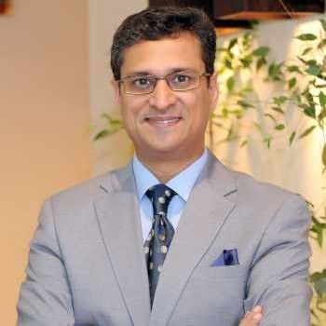
Mr. Neeraj Mahajan as Group President – Group Marketing | Mr. Arvind Chandra as the CEO - Business Vertical 1 (Mechatronics).

Mr. Ashok Minda, Chairman & Group CEO, Minda Corporation Limited said, “I am very excited to onboard such accomplished business leaders having rich industry experience of 25 to 30 years and strong relationships with eminent Indian & Global customers. I am very sure, with their rich experience and customer centric approach; they will strengthen our relationships and continue to delight our customers with best of our offerings to be recognized as a leading Innovative System Solution provider. We have enhanced our focus on operational excellence, customer centricity and speedy market responsiveness.”

The Spark Minda senior leadership team is now geared up to enhance the trust, faith and confidence of our stakeholders. They will continue to create new benchmarks, innovative and technologically advanced products and be the supplier of choice in the auto industry. The state of the art innovation center, Spark Minda Technical Center (SMIT) located in Pune, India is committed to facilitate OEMs in improving their technology offering to improve the final quality of their products, to meet the growing aspirations of consumers and regulatory challenges.

About Spark Minda Group

Spark Minda Group is one of the leading manufacturers of automotive components for the OEMs with Headquarters in India, Gurgaon- near to New Delhi. The Group was founded in 1958 by Late Shri. S.L. Minda and today has over 6 decades of legacy as an automotive component manufacturing company. The group is one of the leading manufacturers of automotive components under these four Categories – Mechatronics, Information & Connected Systems, Plastics & Interiors and Aftermarket. The Group caters to major two, four-wheeler, commercial, Tractor and off-road vehicles manufacturer in India and Overseas market including Europe, US, CIS & ASEAN countries with 34 state of the art manufacturing plants.

For more information, please refer to below links:
About the Group - http://sparkminda.com/

For further assistance, please contact –

Ms. Subhalaxmi Das
Group Head Corporate Communication and PR, Spark Minda Group
Plot No 404 and 405, Udyog Vihar Phase-iii, Gurugram, Haryana 122016
Mob: +91-7428532455

Email ID: subhalaxmi.das@mindacorporation.com

